Cloudant-DB

Creating service credentials

|  |  |
| --- | --- |
| Date | 19 September 2022 |
| Team ID | PNT2022TMID27630 |
| Project Name | VirtualEye - Life Guard for Swimming Pools to Detect Active Drowning |
| Maximum Marks | 4 Marks |

You can find the credentials for any service that is associated with your account. **Objectives**

* Locate your service credentials in IBM Cloud.
* Understand your service credentials.

# Prerequisites

• Create a service instance in the IBM Cloud dashboard by following the Getting started with IBM Cloudant tutorial.

# Step 1: How to find your service credentials

1. Go to IBM Cloud and log in.

|  |
| --- |
| Cloudant-o7 |

1. Find the service instance called and open it.

This instance is the one you created as a prerequisite.

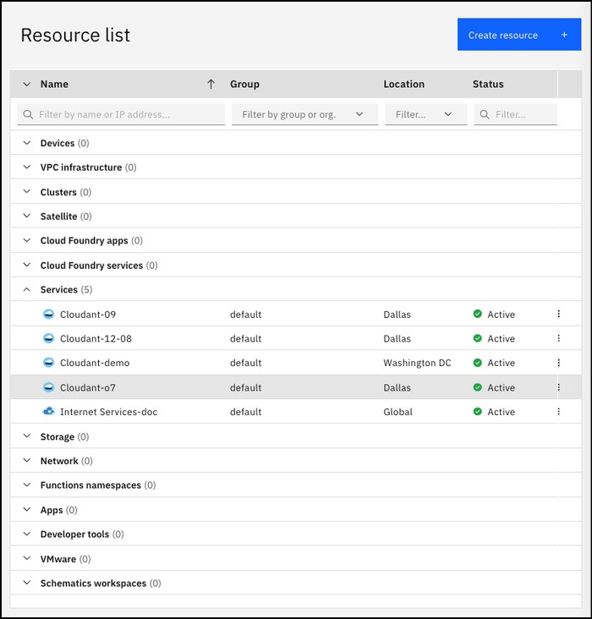

Figure 1. Selecting the IBM Cloudant service

1. Click **Service credentials**.
2. Click the chevron next to the service credentials to see the credentials that are required to access the service.

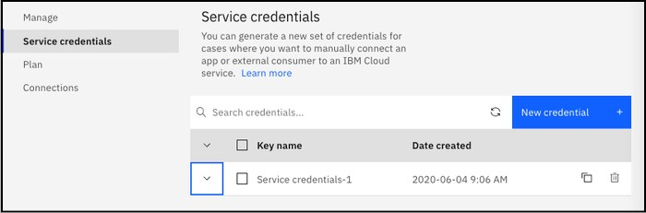

Figure 2. Viewing the IBM Cloudant service credentials Now, you can see the service credentials:

